# MODULE: 1

# SE – Overview of IT Industry

1. What is software? What is software engineering?

**Software** refers to a collection of programs that perform specific tasks on a computer system. [Software engineering is a branch of computer science that combines engineering principles with knowledge of programming languages to create software solutions for end users](https://www.geeksforgeeks.org/software-engineering/)

1. Explain types of software

SYSTEM SOFTWARE

• It is designed to operate the computer hardware efficiently.

• Provides and maintains a platform for running application software.

• Examples: Windows, Linux, Unix etc.

APPLICATION SOFTWARE

• It is designed to help the user to perform general task such as word processing, web browser etc.

• Examples: Microsoft Word, Excel, PowerPoint etc.

1. What is SDLC? Explain each phase of SDLC

The **Software Development Life Cycle (SDLC)** is a systematic methodology used by development teams to create high-quality software.

**Planning & Analysis**:

* During this initial phase, the project team gathers business requirements from clients or stakeholders.

**Requirements Definition**:

* In this critical phase, the information collected during planning and analysis is transformed into clear requirements for the development team

**Design**:

* The design phase focuses on creating architectural and detailed designs for the software.

**Development**:

* The actual coding and development of the software occur in this phase.

**Testing**:

* Quality assurance and testing are crucial to ensure that the software functions correctly.

**Deployment**:

* Once the software passes testing, it is deployed to the production environment.

**Maintenance**:

* After deployment, ongoing maintenance and support are necessary.

1. What is DFD? Create a DFD diagram on Flipkart

A **Data Flow Diagram (DFD)** is a graphical representation that maps out the flow of information within a process or system. It helps us understand how data is processed, stored, and communicated

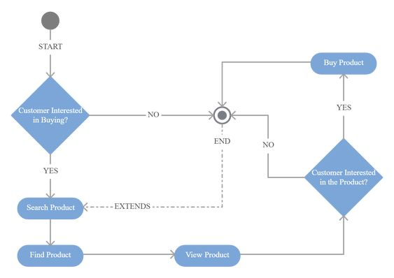

1. What is Flow chart? Create a flowchart to make addition of two numbers

Flowchart is a pictorial or graphical representation of a program.

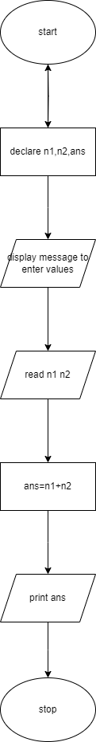



1. What is Use case Diagram? Create a use-case on bill payment on paytm.

A **Use Case Diagram** is a type of **Unified Modeling Language (UML)** diagram that represents the interaction between actors (users or external systems) and a system under consideration to accomplish specific goals

$$+$$